

AMERICAN INTERNATIONAL UNIVERSITY–BANGLADESH (AIUB)
Dept. of Computer Science
Faculty of Science and Technology
CSC 2210: OBJECT ORIENTED PROGRAMMING 2
Fall 2025-2026
Section: II
Group No: 08

Project Report On
University Event Volunteer and Management System

Supervised By
Saikat Baul

Submitted By:
Name | ID
1. Irtiza yesmeen | 23-55574-3
2. Ahnaf Ahmad | 23-53414-3
3. Imamul Shihab | 23-53114-3
4. Nusrat Jahan Labonno | 18-36688-1

CO2: Display and verify the mean of a real-life Project using the concepts of C# Graphical User Interface based environment with database integration to depict a desktop-based application.
Assessment  Criteria | Not Attended/ Incorrect (0) | Inadequate  (1-2) | Average  (3) | Good  (4) | Excellent  (5)
Evaluation Criteria | Evaluation Definition |  |  |  | Total =
Requirement fulfillment | Properly demonstrate a real-life scenario-based project with proper functional requirement identification for the Object-Oriented Programming project development activities.
Validation | Ensuring the ability of students’ proper demonstration on validation forms in their system in terms of dealing with the data.
Verification | Identifying if the students can verify the system data along with proper functional requirements in terms of data flow.

Table of Contents

1. INTRODUCTION 2
2. FEATURE LIST 3
2.1 User 1 4
2.2 User 2 4
2.3 User 3 4
3. ER DIAGRAM 4
3.1 Normalization 5
3.2 Finalization 5
4. UML DIAGRAM 5
4.1 Use Case Diagram 6
4.2 Activity Diagram. 6
5. CONCLUSION 6

INTRODUCTION
Welcome to the AIUB Event and Volunteer Management System. This platform is a user-friendly system designed to simplify and enhance the coordination of university events by organizing volunteer activities and student participation efficiently.

The system provides a centralized database that tracks Administrators, Event Organizers, Volunteers, and Students, ensuring seamless coordination and smooth event operations. The system defines three main user roles: Admin, Event Organizer, and Volunteer.

- The Admin oversees the entire platform, managing accounts for Organizers and viewing high-level system statistics to ensure security.

- The Event Organizer is responsible for creating tasks (such as stage setup or schedule checks) and assigning them to registered volunteers.

- The Volunteer can manage student lists, register new participants for events, and view/complete tasks assigned to them by Organizers

FEATURE LIST

2.1.Admin Features

Module | Functionality
Dashboard | View overall system status and total volunteer/organizer statistics.
User Management | Add, update, and manage Event Organizer profiles and secure system access.
Event Oversight | Monitor all active university events and total student participation counts.

2.2.Event Organizer Features
Module | Functionality
Task Management | Create and assign specific tasks (e.g., "Fix Set") to available volunteers.
Volunteer Tracking | Monitor volunteer progress on assigned tasks and update task requirements.
Schedule Review | Check and update event timelines and volunteer shifts.

2.3. Volunteer Features
Module | Functionality
Student Management | Register new students for events and maintain the active student list.
Task Dashboard | View assigned tasks, deadlines, and mark tasks as "Completed".
Profile Access | Sign in, Sign up, and manage personal volunteer availability.

ER DIAGRAM
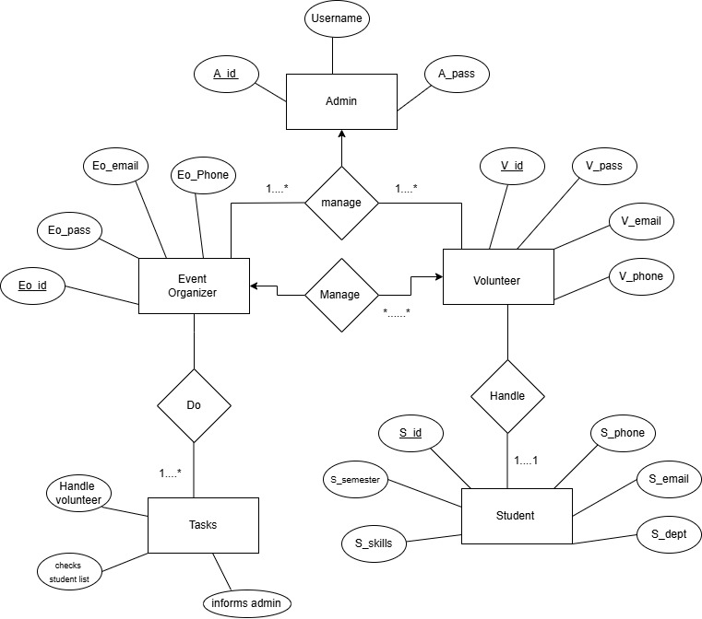

Normalization
1NF

Admin(A_id PK, Username, A_pass)

Event_Organizer(Eo_id PK, Eo_email, Eo_phone, Eo_pass)

Volunteer(V_id PK, V_email, V_phone, V_pass)

Student(S_id PK, S_email, S_phone, S_dept, S_semester)

Student_Skills(Skill_id PK, S_id FK, Skill_Name)

Tasks(Task_id PK, Handle_volunteer, Checks_student_list, Informs_admin)

2NF

Admin_Manages_Organizer(A_id FK, Eo_id FK)

Admin_Manages_Volunteer(A_id FK, V_id FK)

Organizer_Manages_Volunteer(Eo_id FK, V_id FK)

Volunteer_Handles_Student(V_id FK, S_id FK)

Organizer_Does_Tasks(Eo_id FK, Task_id FK)

Finalization

1. Admin Table Stores the highest level of authority in the system.
- A_id (PK): Unique identifier for each Admin.
- Username: The login name for the admin.
- A_pass: The encrypted password for system access.

2. Event Organizer Table Stores details of the staff members who create and manage tasks.
- Eo_id (PK): Unique ID for the organizer.
- Eo_email: Professional email address.
- Eo_pass: Login password.
- Eo_Phone: Contact number.
- A_id (FK): Links to the Admin who manages this organizer.

3. Volunteer Table Stores information for students acting as event workers.
- V_id (PK): Unique ID for the volunteer.
- V_email: University email.
- V_pass: Access password.
- V_phone: Contact number.
- A_id (FK): Links to the Admin who manages the volunteers.

4. Tasks Table Represents the specific work assigned within the event
- Task_ID (PK): Unique identifier for each task.
- Task_Description: Details such as "Handle volunteer," "Checks student list," or "Informs admin".
- Eo_id (FK): Links to the Event Organizer who "Does" (creates/assigns) the task.

5. Student Table Stores the data of students being registered or handled during events.
- S_id (PK): Unique student identification number.
- S_semester: Current academic semester.
- S_skills: Specific skills relevant to the event.
- S_dept: Academic department.
- S_email & S_phone: Student contact details.
- V_id (FK): Links to the Volunteer who "Handles" the student registration.

